**Week-5 Microservices**

**Creating Microservices for account and loan**

**1)Account**

**AccountApplication.java**

package com.cognizant.account;

import org.springframework.boot.SpringApplication;

importorg.springframework.

boot.autoconfigure.SpringBootApplication;

@SpringBootApplication

public class AccountApplication {

public static void main(String[] args) {

SpringApplication.run(AccountApplication.class, args);

}

}

**Controller.java**

package com.cognizant.account;

import org.springframework.web.bind.annotation.GetMapping;

import org.springframework.web.bind.annotation.PathVariable;

import org.springframework.web.bind.annotation.RestController;

import java.util.HashMap;

import java.util.Map;

@RestController

public class Controller {

@GetMapping("/accounts/{number}")

public Map<String, Object> getAccountDetails(@PathVariable String number) {

Map<String, Object> response = new HashMap<>();

response.put("number", number);

response.put("type", "savings");

response.put("balance", 234343);

return response;

}

}

**AccountApplicationTests.java**

package com.cognizant.account;

import org.junit.jupiter.api.Test;

import org.springframework.boot.test.context.SpringBootTest;

@SpringBootTest

class AccountApplicationTests {

@Test

void contextLoads() {

}

}

**Pom.xml**

<?xml version="1.0" encoding="UTF-8"?>

<project xmlns="http://maven.apache.org/POM/4.0.0" xmlns:xsi="http://www.w3.org/2001/XMLSchema-instance"

xsi:schemaLocation="http://maven.apache.org/POM/4.0.0 https://maven.apache.org/xsd/maven-4.0.0.xsd">

<modelVersion>4.0.0</modelVersion>

<parent>

<groupId>org.springframework.boot</groupId>

<artifactId>spring-boot-starter-parent</artifactId>

<version>3.5.3</version>

<relativePath/> <!-- lookup parent from repository -->

</parent>

<groupId>com.cognizant</groupId>

<artifactId>account</artifactId>

<version>0.0.1-SNAPSHOT</version>

<name>account</name>

<description>Demo project for Spring Boot</description>

<url/>

<licenses>

<license/>

</licenses>

<developers>

<developer/>

</developers>

<scm>

<connection/>

<developerConnection/>

<tag/>

<url/>

</scm>

<properties>

<java.version>21</java.version>

</properties>

<dependencies>

<dependency>

<groupId>org.springframework.boot</groupId>

<artifactId>spring-boot-starter-web</artifactId>

</dependency>

<dependency>

<groupId>org.springframework.boot</groupId>

<artifactId>spring-boot-devtools</artifactId>

<scope>runtime</scope>

<optional>true</optional>

</dependency>

<dependency>

<groupId>org.springframework.boot</groupId>

<artifactId>spring-boot-starter-test</artifactId>

<scope>test</scope>

</dependency>

</dependencies>

<build>

<plugins>

<plugin>

<groupId>org.springframework.boot</groupId>

<artifactId>spring-boot-maven-plugin</artifactId>

</plugin>

</plugins>

</build>

</project>

**application.properties**

spring.application.name=account

**Output:** **http://localhost:8080/accounts/00987987973432**

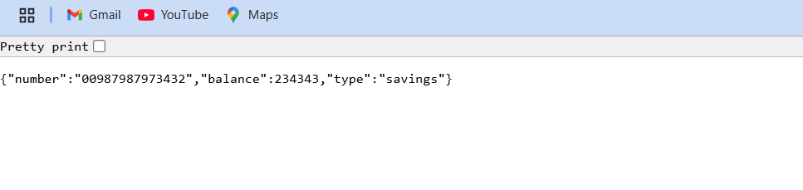

**2)Loan**

**LoanApplication.java**

package com.cognizant.loan

import org.springframework.boot.SpringApplication;

import org.springframework.

boot.autoconfigure.SpringBootApplication;

@SpringBootApplication

public class LoanApplication {

public static void main(String[] args) {

SpringApplication.*run*(LoanApplication.class, args);

}

}

**Controller.java**

package com.cognizant.loan;

import org.springframework.web.bind.annotation.GetMapping;

import org.springframework.web.bind.annotation.PathVariable;

import org.springframework.web.bind.annotation.RestController;

import java.util.HashMap;

import java.util.Map;

@RestController

public class Controller {

@GetMapping("/loans/{number}")

public Map<String, Object> getLoanDetails(@PathVariable String number) {

Map<String, Object> response = new HashMap<>();

response.put("number", number);

response.put("type", "car");

response.put("loan", 400000);

response.put("emi", 3258);

response.put("tenure", 18);

return response;

}

}

**LoanApplicationTests.java**

package com.cognizant.loan;

import org.junit.jupiter.api.Test;

import org.springframework.boot.test.context.SpringBootTest;

@SpringBootTest

class LoanApplicationTests {

@Test

void contextLoads() {

}

}

**Pom.xml**

<?xml version="1.0" encoding="UTF-8"?>

<project xmlns="http://maven.apache.org/POM/4.0.0" xmlns:xsi="http://www.w3.org/2001/XMLSchema-instance"

xsi:schemaLocation="http://maven.apache.org/POM/4.0.0 https://maven.apache.org/xsd/maven-4.0.0.xsd">

<modelVersion>4.0.0</modelVersion>

<parent>

<groupId>org.springframework.boot</groupId>

<artifactId>spring-boot-starter-parent</artifactId>

<version>3.5.3</version>

<relativePath/> <!-- lookup parent from repository -->

</parent>

<groupId>com.cognizant</groupId>

<artifactId>loan</artifactId>

<version>0.0.1-SNAPSHOT</version>

<name>loan</name>

<description>Demo project for Spring Boot</description>

<url/>

<licenses>

<license/>

</licenses>

<developers>

<developer/>

</developers>

<scm>

<connection/>

<developerConnection/>

<tag/>

<url/>

</scm>

<properties>

<java.version>21</java.version>

</properties>

<dependencies>

<dependency>

<groupId>org.springframework.boot</groupId>

<artifactId>spring-boot-starter-web</artifactId>

</dependency>

<dependency>

<groupId>org.springframework.boot</groupId>

<artifactId>spring-boot-devtools</artifactId>

<scope>runtime</scope>

<optional>true</optional>

</dependency>

<dependency>

<groupId>org.springframework.boot</groupId>

<artifactId>spring-boot-starter-test</artifactId>

<scope>test</scope>

</dependency>

</dependencies>

<build>

<plugins>

<plugin>

<groupId>org.springframework.boot</groupId>

<artifactId>spring-boot-maven-plugin</artifactId>

</plugin>

</plugins>

</build>

</project>

**application.properties**

spring.application.name=loan

server.port=8081

**Output:**

[**http://localhost:8081/loans/H00987987972342**](http://localhost:8081/loans/H00987987972342)

